Specifications for safety testing

Insofar as they apply to the installation/machine supplied, performance
of the following tests is mandatory:

- Initial electrical testing in accordance with VDE 0113-1 (DIN EN ISO 60204)
and VDE 0100-600
- A detailed list of the measurements to be taken is given in the annex.

- Initial inspection and initial testing of electro-sensitive protective equipment in accordance with DIN EN 62046 / VDE 0113-211 / Provision on Operating Safety (BetrSichV)
- Stopping performance is to be measured in accordance with DIN EN ISO 13855.

- Checking of ESD capability in accordance with DIN EN ISO 61340-5-1
- The discharge resistances of setting-down surfaces and the field strengths
of individual insulators are to be measured

- Testing of the closing force of power-operated guards in accordance with
DIN EN ISO 14120
- The actual closing force is to be measured.

All measurements are to be taken by a person qualified to perform the corresponding test.
Use is to be made of measuring instruments that comply with the applicable standards.
All tests are to be documented with the corresponding measured values and submitted to ebm-papst on acceptance of the installation/machine.
If the installation/machine is fully or partially disassembled for transportation, renewed testing (item 1) must be performed at the assembly location.

Annex to item 1
The measurement protocol to be supplied must list all the measurements performed (measurement points), as well as the reference point for each measurement.
The following measurements are to be performed:
- Low-resistance measurement (protective earth resistance, equipotential bonding)
in accordance with VDE 0113-1/18.2.2
Test current: min.10 A

- Insulation resistance measurement in accordance with VDE 0113-1/18.3
Measurements are to be taken on all the conductors of the main circuit.

- Voltage measurement (HV) in accordance with VDE 0113-1/18.4
Measurements are to be taken on all the conductors of the main circuit.
Assemblies and devices not designed to withstand this test and overvoltage protectors that would probably be triggered during measurement were disconnected before the test.
Assemblies and devices subjected to voltage testing on the basis of the applicable product standards can be disconnected during the test.

- Leakage current measurement
Measurement method: Measurement of current difference between phase and neutral conductors.
True RMS measurement.
In the case of measured values ≥10 mA TRMS, a connection is to be provided for additional equipotential bonding on or in the switch cabinet.
- Ground fault loop impedance and system impedance measurement
in accordance with VDE 0100-600
Measurements are to be taken on all protected current paths of the main circuit. At the connection furthest away in each case.
The reference value of the connection point during the measurement is also to be documented.

- Residual voltage measurement in accordance with VDE 0113-1/6.2.4
If a hazardous residual voltage still remains after the corresponding decay time, this is to be clearly marked on the switch cabinet.

- RCD measurement in accordance with VDE 0100-600
Measurements are to be taken with the corresponding tripping currents depending on the type of RCD.

The ebm-papst Mulfingen internal test log is appended
to this document. It can be used as a specimen log.
Usage is not obligatory!

Test log for the safety testing of the electrical equipment of machines

Log number: (Installation number_date)

Details of test object
Machine: |  | Year of manufacture:
Manufacturer: |  | Installation number:
Place of testing: |  | Inventory number:
Type of testing: | Initial test  Repeat test  Testing following modification or repair  Only partial testing required | Order number:
General remarks:

Tests carried out:

Yes No Not applicable

Initial electrical testing in accordance with VDE 0113 Annex 1

Initial inspection and testing of
electro-sensitive protective equipment Annex 2

Testing of ESD capability Annex 3

Testing of closing force of automatically closing guards Annex 4

Completeness of documentation Annex 5

Annex 1 Initial electrical testing and repeat testing

References to laws and standards: Provision on Operating Safety (BetrSichV), § 5 DGUV regulation 3
VDE 0113-1 / DIN EN 60204-1 / IEC 204-1 VDE 0100-600
VDE 0701-0702

Initial test Repeat test

Technical specifications
Nominal voltage V: |  | Remarks:
Nominal current A:
Rated output VA:
Back-up fuse A:

This test log confirms the proper performance of all tests prescribed within the scope of the quoted standards on acceptance of the above-mentioned electrical machine / installation.

Testing was performed by a qualified person meeting the requirements as per DIN VDE 0105 Part 1/5.75, item 3.2.1.

The machine/installation tested meets the requirements of DIN VDE 0113/EN 60204-1/IEC 204-1
in every respect.

OK Not OK Not applicable

1.1 Visual inspection
1.1.1 General design features
1.1.2 Electrical equipment
1.1.3 Machine/installation

1.2 Measurements

1.2.1 Low-resistance measurement (protective earth resistance, equipotential bonding)
1.2.2 Ground fault loop impedance/system impedance measuring
1.2.3 Insulation resistance measuring
1.2.4 Voltage measuring (HV)
1.2.5 Residual voltage measuring
1.2.6 Leakage current measuring
1.2.7 RCD measuring

1.3 Testing of function and functional safety

Name

Date

Signature

Place

Name

Date

Signature

Place

Measuring instruments used:

No.: | 1 | 2 | 3 | 4
Manufacturer:
Type:
Serial no.:
Last calibration:

Information on place of testing/measurements:

Connection location:
System configuration:
Sub-distribution:
Connection point designation:

Reference measurements:

Measuring instrument used:

 |  | Impedance | Short-circuit current
Fault impedance measurement | L1 – PE | mΩ | A
 | L2 – PE | mΩ | A
 | L3 – PE | mΩ | A
System  impedance  measurement | L1 - L2 | mΩ | A
 | L2 - L3 | mΩ | A
 | L1 - L3 | mΩ | A
 | L1 – N | mΩ | A
 | L2 – N | mΩ | A
 | L3 – N | mΩ | A

Comments:

Visual inspection
    - General design features

OK Not OK Not Remarks
applicable

Name plate affixed

Labeling of control elements and emergency stop in local language

Attachment/accessibility of control element

Attachment/accessibility of main switch and emergency stop button

Accessibility of electrical equipment

Cleanliness, general condition

Labeling of pneumatic components

Pneumatic diagram in document pouch

Comments:

    - Electrical equipment (switch cabinet, panel, terminal box)
Bemerkungen:

OK Not OK Not Remarks
applicable

Equipment marked

Equipment installation location marked

Equipment installed as per manufacturer's specifications

Logical arrangement of equipment

Terminal strips labeled

Terminals labeled

Wires labeled at connection point

Warning notes / signs affixed (in local language)

Plug-in lines labeled

Line dimensioning

Wire colors (in accordance with internal standard)

Marking of non-disconnected circuits

Spatial separation of different voltage levels

Marking of protective earth connections

Electrically conductive parts grounded

Additional grounding of electric drives

Protection against direct contact

Extra-low voltage SELV / PELV

Selectivity of overcurrent protectors

Dimensioning of switch cabinet cooling

Additional equipotential bonding provided and marked
Comments:

    - Machine / installation electrical equipment

OK Not OK Not Remarks
applicable

Equipment marked

Equipment fitted as per manufacturer's specifications

Cables / sheathed cables marked

Warning notes / signs affixed (in local language)

Line dimensioning

Selection of lines and method of laying

Marking of protective earth terminals

Equipotential bonding (item sections and doors) fitted

Electrically conductive parts grounded

Protection against direct contact

Plug-in connection secured against self-opening

Equipotential bonding strip fitted and labeled
Comments:

  - Measuring

    - Low-resistance measuring (protective earth resistance,
equipotential bonding) in accordance with VDE 0113-1/18.2.2

Measuring instrument used: 1 2 3 4

Test current: 10A AC ≥200mA AC ≥200mA DC

Test duration: 5 sec.

mΩ
Measuring instrument offset:
The specified limit value corresponds to values such as length, cross-section and material of the relevant protective earth. The test duration and the limit value for the permissible protective earth resistance are listed for the individual measurement points.
Number of measurements performed:
Measurement reference point:
No. | Measurement point |  | Specified limit value  in mΩ | Resistance measured value  in mΩ | Assessment
 |  |  |  |  | OK | Not OK
1
2
3
4
5
6
7
8
9
10
11
12
13
14
15
16
17
18
19
20
21

No. | Measurement point | Specified limit value  in mΩ | Resistance measured value  in mΩ | Assessment
 |  |  |  | OK | Not OK
22
23
24
25
26
27
28
29
30
31
32
33
34
35
36
37
38
39
40
41
42
43
44
45
46
47
48
49
50
51
52
53
54
55
56
57
58
59
60
61
62
63
64
65

    - Ground fault loop impedance/system impedance measurement
VDE 0113-1/18.2.3

Measuring instrument used: 1 2 3 4

The connection point and its reference values are listed on Page 2 of the log.
Calculations:
*1 | Tripping current | I_{a}=K x I_{N}
*2 | Max. impedance | 2/3 U_{L-PE} / I_{a}  2/3 _{UL-L(N)} / I_{a}
*4 | Machine impedance | *2 - *3 = *4
Measurement values have been measured at the farthest point of the respective protection device. With integrated RCD, ground fault loop impedance may be omitted.

Number of measurements performed: |  |  |  |  |  | *1 |  | *2 |  | *3 | *4
No | Measurement  Point/terminal/circuit |  |  | Protective  Device  Type | Nominal Current | K-  Factor | Tripping current in A | max. Impedance  in mΩ | Measured value  In mΩ  Z_{SCH} / Z_{I} | Reference measurement  See  p.2 | Machine  impedance | Assessment
 |  |  |  |  |  |  |  |  |  |  |  | OK | Not  OK
 | Designation | Pt.  1 | Pt.  2
1
2
3
4
5
6
7
8
9
10
11
12
13
14
15
16
17
18
19
20
21
22
23
24
25
26
27
Comments:

    - Insulation resistance measurement in accordance with 0113-1/18.3

Measuring instrument used: 1 2 3 4

Test voltage: 500V DC 250V DC

The phase conductors of the supply line/supply terminals and the neutral conductor were connected together
for the measurement. All main circuit switching devices were actuated.
Further measurements are listed in the measured value table.

Number of measurements performed:
No. | Connection / terminal / circuit |  |  | Specified limit value  in MΩ | Resistance measured value in MΩ | Assessment
 | Designation | Connection |  |  |  | OK | Not  OK
1
2
3
4
5
6
7
8
9
10
11
12
13
14
15
16
17
18
19
20
Comments:

    - Voltage measurement (HV) in accordance with VDE 0113-1/18.4

Measuring instrument used: 1 2 3 4

Test voltage: 1000V AC

Test duration: 1 second

Assemblies and devices not designed to withstand this test and overvoltage protectors that would probably be triggered during measurement were disconnected before the test.
Assemblies and devices subjected to voltage testing on the basis of the applicable product standards can be disconnected during the test.
The phase conductors of the supply line/supply terminals and the neutral conductor were connected together for the measurement. All main circuit switching devices were actuated.
Further measurements are listed in the measured value table.

Number of measurements performed:
No. | Connection / terminal / circuit |  |  | Measured value  in mA | Assessment
 | Designation | Connection |  |  | OK | Not OK
1
2
3
4
5
6
7
8
9
10
11
12
13
14
15

Comments:

    - Residual voltage measurements in accordance with VDE 0113-1/18.5 (6.2.4)

Measuring instrument used: 1 2 3 4

Safe isolation of the machine/installation from the supply following shut-off/disconnection of the supply was measured and the time taken for the voltage to decay to a value of less than 60 V was determined.
With permanently installed machines or systems, residual voltage measuring can be omitted if protection against accidental contact as per IP20 is complied with.

Limit values: 1 sec 5 sec

1 second Plug-in cable, measurement taken at terminals of cable
5 seconds Residual voltage in closed housing, corresponding
measurement point was recorded in measured value table.

Number of measurements performed:
No. | Measurement point / terminal / circuit |  |  |  | Measured value  Time until U < 60 V  in s | Residual voltage  after 1 s/5 s  in V | Assessment
 |  |  |  |  |  |  | OK | Not OK
 | Designation | Pt. 1 | Designation | Pt. 2
1
2
3
4
5
6
7
8
9
10
11
12
13
14
15
16
17
18
19
20
Comments:

    - Leakage current measurement

Measuring instrument used: 1 2 3 4

Measurement method: Measurement of current difference between phase and neutral conductors.
True RMS measurement.

Number of measurements performed:
No. | Measurement point / circuit / equipment |  | Measured value  in mA | Assessment
 |  |  |  | OK | Not OK
1
2
3
4
5
6
7
8
9
10
11
12
13
14
15

- Highest measured value >3.5 mA
A warning notice is required.

- Highest measured value ≥ 10 mA,
additional equipotential bonding required.
A warning notice is required.

- Highest measured value ≥ 10 mA and cross section of the protective earth ≥ 10mm²
        - Additional equipotential bonding not required with permanently installed supply line.
A warning notice is required!
        - Additional equipotential bonding required with plug-in supply line.
A warning notice is required!
Comments:

    - RCD measurement

Measuring instrument used: 1 2 3 4

Test current: 1) AC ramp (0.3 – 1.3 x I_{∆N}) 4) DC ramp (0.3 – 1.3 x I_{∆N})
2) 1 x I_{∆N} AC 5) 1 x I_{∆N} DC
3) 5 x I_{∆N} AC

Note on measurements to be performed: RCD Type A: Test current 1) - 3)
RCD Type B: Test current 1) - 5)

Number of measurements performed:
No. | Equip. ID | Type | Nominal current  IN in A | Nominal fault current  I∆N in mA |  | Test current  1) - 6) | Measured value  Ia in mA | Measured value  ta in ms | Measured value  RE in Ω | Measured value  UB in V | Assessment
 |  |  |  |  |  |  |  |  |  |  | OK | Not OK
1
2
3
4
5
6
7
8
9
10
11
12
13
14
15
16
17
18
Comments:

  - Testing of functional safety

OK Not OK Not Remarks
applicable

Emergency stop function Shut-off

Emergency stop function of main switch (if red-yellow)

Acknowledgment required after emergency stop

All fixed protective devices fitted

All removable protective devices monitored

No start-up with open guard/protective device

Electrical interlocking of guards/protective device

Two-hand control fitted as per normative regulations

Interruption of electro-sensitive protective equipment stops movement

Main circuit voltages tested

Rotating field tested

Control circuit voltages tested (SELV/PELV)

Comments:

Annex 2 Initial inspection and testing of electro-sensitive
protective equipment

Initial inspection and testing of electro-sensitive protective equipment
in accordance with DIN EN 62046 / VDE 0113-211 / DIN EN ISO 13855 /
Provision on Operating Safety (BetrSichV)

Initial inspection and testing successful Initial inspection and testing not successful

The test only relates to proper functioning, fitting and incorporation of the electro-sensitive protective equipment into the control system. It is not a substitute for machine safety testing. Modifications to the electro-sensitive protective equipment or the machine/installation render this initial inspection and test invalid. The initial inspection and test must then be repeated.
Comments:

Table of contents:
2.1. Details of the installation 21
2.2. Details of the control system 21
2.3. Assessment of protective device and hazard spot(s) 22
2.3.1. Details and checking of the protective device 22
2.3.2. Structure and assessment of hazard spots: 23
2.3.3. Stopping performance measurement protocol 27
3.1. Definition of dissipation method: 28
3.2. Visual inspection: 28
3.3. Measurement of discharge resistances: 29
3.4. Measuring field strength of insulators: 30

Name

Date

Signature

Place

Name

Date

Signature

Place

Details of the installation
Machine: |  |  |  |  |  |  | Installation number:
Manufacturer: |  |  |  |  |  |  | Inventory number:
Cost center: |  |  |  |  |  |  | Comments:
Site:
Performance level PL: | ◻ a | ◻ b | ◻ c | ◻ d |  | ◻ e
The performance level (PL) of the downstream peripheral equipment corresponds at least to the performance level (PL) of the installation as a whole.
Yes |  |  |  |  | No

Details of the control system
Type of control: | ◻ Programmable |  | ◻ Conventional |  |  | Manufacturer:
Programmer: |  |  |  |  |  | Type:
Mode of operation: | ◻Protective mode |  |  | ◻Single break |  |  |  | ◻Double-break
 | ◻With parts monitoring |  |  | ◻Manual Start |  |  |  | ◻Other
Restart interlock: | ◻OK |  |  | ◻Not OK |  |  |  | ◻Not applicable
External device monitoring: | ◻OK |  |  | ◻Not OK |  |  |  | ◻Not applicable
Equipment ID:
Performance level PL: | ◻ a | ◻ b |  |  | ◻ c |  | ◻ d |  |  | ◻ e

Assessment of protective device and hazard spot(s)

Details and checking of the protective device
Type of protective device:
Manufacturer:
Type:
Serial number:
Performance level: | ◻ a | ◻ b |  | ◻ c |  |  | ◻ d | ◻ e
Response time:
Detection capability:
Equipment ID:
Range:
Installation position: | ◻ horizontal |  | ◻ vertical |  |  | ◻ diagonal
Deflection mirror provided: | ◻ Yes |  |  |  | ◻ No
Does the protective device have a safety-relevant function? | ◻ Yes |  |  |  | ◻ No
Cascading: | ◻ OK |  | ◻ Not OK |  |  | ◻ Not applicable
Muting: | ◻ OK |  | ◻ Not OK |  |  | ◻ Not applicable
Blanking: | ◻ OK |  | ◻ Not OK |  |  | ◻ Not applicable
Restart interlock (internal): | ◻ OK |  | ◻ Not OK |  |  | ◻ Not applicable
External device monitoring (internal): | ◻ OK |  | ◻ Not OK |  |  | ◻ Not applicable
Protective device attached as per manufacturer's specifications: | ◻ OK |  | ◻ Not OK |  |  | ◻ Not applicable
Protective device electrically wired as per manufacturer's specifications: | ◻ OK |  | ◻ Not OK |  |  | ◻ Not applicable
Protective device checked for damage: | ◻ OK |  | ◻ Not OK |  |  | ◻ Not applicable
No reflecting surfaces near and around the protective field: | ◻ OK |  | ◻ Not OK |  |  | ◻ Not applicable
Protective device effective in all modes of operation: | ◻ OK |  | ◻ Not OK |  |  | ◻ Not applicable
Further safety measures taken with disconnectable protective device: | ◻ OK |  | ◻ Not OK |  |  | ◻ Not applicable
Test finger adapted to detection capability (incl. instructions) fitted as per manufacturer's specifications: | ◻ OK |  | ◻ Not OK |  |  | ◻ Not applicable
Connection diagram of installation/machine provided: | ◻ OK |  | ◻ Not OK |  |  | ◻ Not applicable
Protective device wired as per circuit diagram provided: | ◻ OK |  | ◻ Not OK |  |  | ◻ Not applicable
Technical documentation of protective device provided: | ◻ OK |  | ◻ Not OK |  |  | ◻ Not applicable

Protective device used as:

Protective field for orthogonal approach
Protective field for parallel approach
Presence-sensing device
Access control

Structure and assessment of hazard spots:

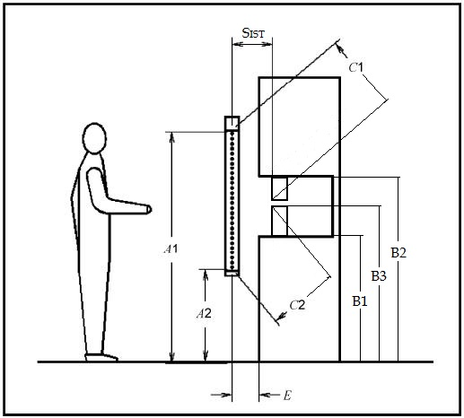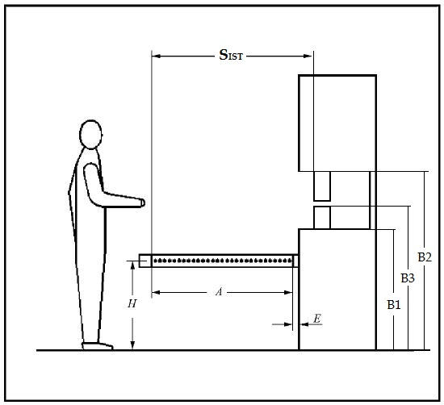
Fig 2: Use as protective field for parallel approach and presence sensing

Fig 1: Use as protective field for orthogonal approach and access control

Dimension
in mm
A | Length of protective field ( A1 – A2 ) |  | ◻ Not applicable
A1 | Top edge of protective field |  | ◻ Not applicable
A2 | Bottom edge of protective field |  | ◻ Not applicable
B1 | Bottom edge of danger zone |  | ◻ Not applicable
B2 | Top edge of danger zone |  | ◻ Not applicable
B3 | Height of hazardous point above floor |  | ◻ Not applicable
E | Distance between protective field and machine body |  | ◻ Not applicable
Sist | Protective field distance from hazardous point |  | ◻ Not applicable
C1 | Protective field distance on reaching over |  | ◻ Not applicable
C2 | Protective field distance on reaching under |  | ◻ Not applicable
H | Height of protective field above floor |  | ◻ Not applicable

1 | Not possible to step behind protective field (dimension E  75 mm) or additional action taken to safeguard the area | ◻ OK | ◻Not OK | ◻ Not applic.
2 | Not possible to reach over protective field Dimension C1 from DIN EN ISO 13855 Table 1 | ◻ OK | ◻Not OK | ◻ Not applic.
3 | Not possible to reach over protective field Dimension C1 from DIN EN ISO 13855 Table 1 | ◻ OK | ◻Not OK | ◻ Not applic.
4 | Not possible to reach around protective field | ◻ OK | ◻Not OK | ◻ Not applic.
5 | Fixed guard | ◻ OK | ◻Not OK | ◻ Not applic.
6 | Guards with interlock correspond to the performance level (PL)  of the machine as a whole | ◻ OK | ◻Not OK | ◻ Not applic.
6.1 | Hazardous movement is stopped after opening a protective device | ◻ OK | ◻Not OK | ◻ Not applic.
6.2 | Restart interlock active after closing the protective device | ◻ OK | ◻Not OK | ◻ Not applic.
7 | Height of danger zone above floor ≤ 750 mm or additional access protection provided | ◻ OK | ◻Not OK | ◻ Not applic.
8 | Accessible danger zone: Bottom edge of protective field (dimension B1)  ≤ 200 mm | ◻ OK | ◻Not OK | ◻ Not applic.
9 | Accessible danger zone: Top edge of protective field (dimension B2)  ≥ 900 mm | ◻ OK | ◻Not OK | ◻ Not applic.
10 | Resetting of restart interlock not possible from danger zone | ◻ OK | ◻Not OK | ◻ Not applic.
11 | Entire hazardous point visible from place of resetting restart interlock | ◻ OK | ◻Not OK | ◻ Not applic.

When “cycle operation” mode is possible, the following items must be checked:

12 | Work area height ≤ 600 mm or work area depth ≤ 1000 mm | ◻ OK | ◻Not OK | ◻ Not applic.
13 | Item 1 must be assessed as being OK | ◻ OK | ◻Not OK | ◻ Not applic.
14 | Item 7 must be assessed as being OK | ◻ OK | ◻Not OK | ◻ Not applic.
15 | Detection capability of protective device ≤ 30 mm | ◻ OK | ◻Not OK | ◻ Not applic.

The following items must be checked in the case of a protective field for parallel approach:

16 | Height of protective field above floor (dimension H) ≥ 200 mm | ◻ OK | ◻Not OK | ◻ Not applic.
17 | Height of protective field above floor (dimension H) ≤ 1000 mm | ◻ OK | ◻Not OK | ◻ Not applic.
18 | Further safety measures taken to protect against crawling underneath (dimension H between 200 mm and 1000 mm) | ◻ OK | ◻Not OK | ◻ Not applic.

Stopping performance measurement protocol

Manufacturer:
Type:
Serial no.:
Last calibration:
Measuring instrument used:

Actuator:
Wire draw encoder | Friction wheel | Light barrier
Relay box | Not applicable

Measurement direction:
Retraction | Extension | Other
Counter-clockwise | Clockwise | Not applicable

Protective device:
Two-hand/door interlock
Light curtain for orthogonal approach
Light curtain for parallel approach
Multi-beam electro-sensitive protective equipment (access control/3D camera system)
Scanner/electro-sensitive protective equipment access protection/pressure-sensitive mat
Press brake

Tool no. fitted (Designation / WZ.(tool) no.):

SPM Point | in mm
Maximum speed | in mm/s
Stopping distance | in mm
Stopping time | in ms
Minimum safety distance S_{MIN} | in mm
Measured Values:

The actual protective field distance S_{IST} from the hazardous point is mm.

The minimum safety distance determined at least corresponds to the actual protective field distance.
Yes | No

Annex 3 Checking of ESD capability

Checking of ESD capability in accordance with DIN EN 61340-5-1
as well as internal guidelines

Details of test object
Machine: |  |  | Tester :
Manufacturer: |  |  | ESD officer :
Installation number: |  |  | Year of manufacture:
Test date / period: | from: |  | to:

- Initial test following completion Repeat test

Definition of dissipation method:
- Charge dissipation takes place via protective grounding of the machine.
- Charge dissipation takes place via a defined equipotential bonding point.

Visual inspection:
OK Not OK Not applicable
- All setting-down surfaces made of ESD-capable material
- All surfaces likely to be used for setting-down designed to be ESD-capable
- All electrically conductive, grounded surfaces covered with dissipative mats
- All transparent cover panels made of dissipative plastic
- ESD-capable rollers/feet fitted
- Grounding point with connection notice provided
- Low-resistance connection point for wrist-strap provided (pushbutton)
- All permanently mounted tools (e.g. screwdrivers) grounded
- All insulators fitted at an adequate distance
- Dissipative components marked (rests, cover panels)
Comments:

Overall test result: OK Not OK

Signature

Date

Place

Signature

Date

Place

Measurement of discharge resistances:

Measuring instrument used:
Manufacturer:
Type:
Serial no.:
Last calibration:

Test voltage: 100 V DC

Limit value: > 1 kΩ und < 1GΩ

Ambient conditions: Temperature: ˚C Relative humidity: %

Number of measurement performed:
Measurement reference point:
No. | Measurement point |  | Measured value | Assessment
 |  |  |  | OK | Not OK
1
2
3
4
5
6
7
8
9
10
11
12
13
14
15
16
17
18
19
20

Comments:

Measuring field strength of insulators:

Measuring instrument used:
Manufacturer:
Type:
Serial no.:
Last calibration:

Before the start of measurement, equipotential bonding (protective earth) was connected to the connection socket of the measuring instrument

Limit value: 50V for every cm from ESD-sensitive component/unit

Number of measurement performed:
No. | Measurement point | Distance from component  in cm | Measured value  in V |  | Assessment
 |  |  |  |  | OK | Not OK
1
2
3
4
5
6
7
8
9
10
11
12
13
14
15
16
17
18
19
20

Comments:

Annex 4 Power-operated guards

Testing of power-operated guards in accordance with
DIN EN ISO 14120 / DIN EN 12453

Details of test object
Machine: |  | Year of manufacture:
Manufacturer: |  | Installation number:
Place of testing: |  | Inventory number:
General comments: |  | Order number:

  - Visual inspection:

OK | Not OK | Not applicable | Remark
 |  |  |  | No dangerous crushing points
 |  |  |  | Adjusters (pressure regulator etc.) secured against manipulation
Comments:

  - Measuring closing force:

Protective device does not open automatically upon contact with a person or object.
Manufacturer:
Type:
Serial no.:
Last calibration:

Measuring instrument used:

Measured closing force (in Newton): __________________ N

Assessment:
Maximum closing force as per DIN EN ISO 14120 may not exceed 75N.

Protective device opens automatically upon contact with a person or an object.
Manufacturer:
Type:
Serial no.:
Last calibration:

Measuring instrument used:

Measured closing force (in Newton): __________________ N

Measured existing closing force remains in force: | longer
 | less than 0.75 seconds
Closing force goes down to <25N in 5 seconds: | Yes
 | No

Assessment:
Maximum closing force as per DIN EN ISO 12453 (see table)
This maximum value as defined in table may only persist for max. 0.75s (= Td).
After Td has elapsed, no force <150N is permitted.
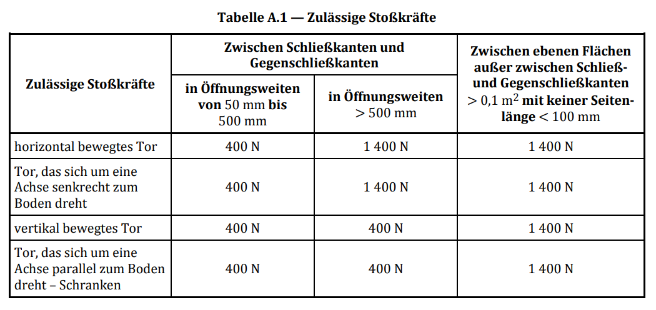
This force must go down to <25N after no longer than 5 seconds.
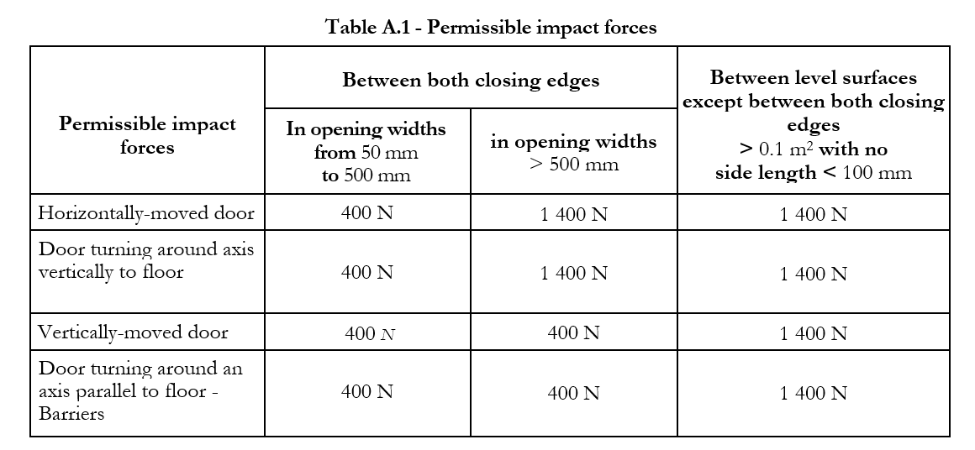
Comments:

  - Functional test with purely pneumatic systems:

OK | Not OK | Not applicable | Comment
 |  |  |  | Testing dual-channel nature of system/device

Comments:

Overall test results: OK Not OK

Name (Constructor)

Date

Signature

Place

Name (Tester)

Date

Signature

Place

Annex 5 Documentation

OK Not Not Not
OK available applicable

Description of machine/installation

Information on installation and assembly

Operating instructions

Servicing and maintenance plan

Connection diagram

Control programs (PC)

Setting instructions for equipment used

Settings for equipment used

Parts list/spare parts list

CE Declaration of Conformity

Test log: Initial electrical testing in accordance with VDE 0113-1

Test log: Initial inspection and testing of electro-sensitive protective
equipment in accordance with Provision on Operating Safety (BetrSichV)

Test log: Stopping performance measurement

Test log: ESD suitability

Test log: Force measurement - Protective devices

Description of procedure in the case of faults/repair

Information on transportation

Information on disposal

Documentation in electronic form

Comments:

