**ebm-papst navigates European economic downturn and changes to heating legislation**

**- Family-owned company consistently focuses its core business   
 on long-term growth**

**- Continues extensive investment in the future**

**- Global market leader pursues its strategy and moves away   
 from non-core business areas**

**- Uses digitalization and AI to enable new business models**

# Mulfingen, 06/19/2024

The ebm-papst Group, a leading global supplier of fans and motors, closed the 2023/24 fiscal year on March 31, 2024, with total sales of 2.408 billion euros. Compared to the previous year, which saw sales of 2.541 billion euros, this represents a decrease of 5.2 percent.

The family-owned company from Baden-Württemberg attributes this decline to several factors: a weak economy in Europe, uncertainties in the German heating technology market, and a challenging macroeconomic environment characterized by geopolitical conflicts. The strategic phase-out of the household appliances and automotive technology business areas, including the rejection of new business in these areas, also had a significant impact.

With its “Making the Future Together” strategy, the technology leader is focusing on its international core segments of air and heating technology as well as on the topics of digitalization and sustainability.

As Klaus Geißdörfer, CEO of the ebm-papst Group, explains: “The strategic realignment of our company is in full swing and is already showing results. By focusing on our growth segments of air and heating technology, supported by our local-for-local strategy and a consistent focus on innovation, we are laying the foundations for a successful long-term future for our company.”

The growth in the ventilation and air conditioning technology segment, which increased by 9.5 percent in the calendar year, is particularly noteworthy. Despite an economically weak first quarter in Europe, this segment achieved an increase in sales at the end of the financial year and reached 1.733 billion euros. ebm-papst is excellently positioned here with highly efficient fans for data centers, cleanrooms, and systems in the field of renewable energies.

At present, the company is suffering in Germany in particular (-4.1 percent to 487 million euros) from the aftermath of the controversial Buildings Energy Act (GEG) and the resulting uncertainty in the markets. The heating technology segment lost 18.7 percent of its sales compared to the previous year and generated 322.9 million euros. “We continue to hope for a clear and practical roadmap for the heating transition in Germany and Europe,” says Geißdörfer. “In addition, the deluge of controls and regulations is paralyzing us everywhere.” In the medium term, ebm-papst expects a boost in this area too, particularly in noise-optimized and highly efficient fans for heat pumps—a business that shows great promise.   
  
The world market leader in fans saw business develop well in the Americas. Business in Asia was also positive and grew to 448.7 million euros.

“Our “Making the Future Together” strategy, which is geared toward sustainable, profitable growth, is paying off,” says Klaus Geißdörfer. “We are continuously expanding our locations in Europe, Asia-Pacific, and the Americas and gearing them towards the local market. We think globally and act locally, which has clear advantages for us: proximity to the customer, independence within the supply chain, and reduced emissions.”   
  
**ebm-papst relies on core workforce and continues to invest in qualified education and further training**

The economic slowdown in Europe combined with faltering demand in the heating technology sector led to lower capacity utilization, particularly at the Eastern European locations and in Mulfingen and Landshut.

In response to the current challenges, ebm-papst has focused on its core workforce, reduced temporary employment and fixed-term contracts, and implemented short-time work in the selected areas of Landshut and Mulfingen.

“Our core workforce is our top priority,” stresses Dr. Sonja Fleischer, Managing Director Human Resources and CHRO of the ebm-papst Group. “With flexible and company-subsidized short-time working models in selected areas, whose extension we review monthly, we are not only securing employment but also the valuable expertise that is crucial for our future growth.

Based on the vision of the ebm-papst “People House,” the company supports its employees and managers with a variety of individual skills development and further training measures. Talented employees are supported in several ways, including through mentoring, specific projects, and national and international training and networks. The advancement of female managers is a particular focus here.

Professional training for students and trainees remains a central component of the company’s efforts to recruit specialists. One focus is on giving young talent full responsibility for important projects at an early stage as “ebm-papst heroes of the future.” The most recent and highly successful examples were the end-to-end organization and implementation of Hannover Messe 2023 and Climate Protection Day 2024 in Heilbronn.   
  
Considering the low birth rate and the declining interest in STEM professions, the integration of skilled workers from abroad is becoming increasingly important for ebm-papst, as once again, not all positions in the commercial and technical areas could be filled this year. For companies like ebm-papst, it is therefore crucial that the hurdles for qualified career entrants from abroad and temporary postings are significantly lowered.

**ebm-papst sets its sights on global growth through extensive investments**

Extensive investments reflect the clear commitment of shareholders and management to take ebm-papst to a new level of growth. At a total of 187 million euros, the innovation leader’s investments remain at a high level.

ebm-papst is also investing heavily in the growth markets in Asia. Around 25 million euros is going into the site expansion in Xi’an, China, where 27,000 square meters of production space will be created. The company had already opened its new China headquarters ONE Shanghai in the spring, and a further location in southern China is already being planned.

As part of this, the fan specialist is consistently pursuing its “local-for-local” strategy to strengthen the Europe, Asia-Pacific, and Americas regions, mapping supply routes locally and setting up locations independently in line with market requirements.

A state-of-the-art IT hub has been established in India, where more than 200 additional IT specialists will be working over the next few years. The company also plans to expand local production capacities to supply the Asia region outside China from India in the future. Singapore was recently expanded as the new Asia-Pacific headquarters. In the US, ebm-papst is planning to further expand its production in Telford, Tennessee and is preparing additional production facilities.

The company is also planning a new air technology site in Oradea, Romania. The 56,000 square meters of land for this construction project has already been acquired, and construction work will begin at the end of the year.

Hans Peter Fuchs, Chief Financial Officer, and CFO of the ebm-papst Group explains the thinking behind these projects: “With these huge investments in our global presence and innovative strength, we are laying the foundation for our growth trajectory in the coming years whilst maintaining an excellent liquidity position. As a leading developer of energy-efficient air and heating technology solutions, we are expanding our position as a world market leader and moving closer to our customers in all regions.”

**ebm-papst reinforces its drive technology division through strategic focusing and planned sale to Siemens**

As part of the investment program, the focusing process, which has been ongoing for two years and is anchored in the corporate strategy, has also meant a necessary strengthening of the IDT drive technology division. The planned sale of this business unit to Siemens will give the division the necessary international market access.

The effects of this sale, whose proceeds are to be used for future growth, will become visible in the coming year, meaning that the one-off effects are not yet reflected in the current figures. According to Klaus Geißdörfer, CEO of ebm-papst: “This sale is a win-win situation for everyone involved: for Siemens, for ebm-papst, for our customers, and, last but not least, for the division’s employees.”

In the medium term, ebm-papst will therefore concentrate exclusively on air and heating technology. “With our “Making the Future Together” corporate strategy, we have laid the foundations for future growth,” adds Geißdörfer. “Within five years, we want to almost double our sales in our core business of air and heating technology to over 3.5 billion euros. We are convinced that we can achieve this target.”

**Moving at high speed towards artificial intelligence**

Innovation, digitalization, and sustainability play a central role here. “We are opening up completely new business areas,” says Chief Technology Officer Prof. Tomas Smetana, CTO of the ebm-papst Group. “Our fans make the overall system even more efficient, but they also make it smarter. Predictive fan monitoring and system control allow additional energy to be saved and maintenance intervals to be optimized.”

In addition to the new system business, ebm-papst is also focusing on the modernization and replacement of existing systems, which offers huge potential for savings. Retrofitting will also result in energy savings of at least ten percent at the company’s locations, with the investment paying for itself within a few years. ebm-papst will also be able to leverage further potential savings through data-supported, demand-driven systems operation, which has a positive effect on its carbon footprint.

The operating data from countless fans and sensors in the field also form the basis for AI applications with completely new data-driven services for customers. “We continue to provide cooling and fresh air. But the key value drivers of the future lie in the intelligent data that our systems generate in customer applications and that enable systems to be operated with optimum efficiency,” says Smetana. “What counts now is maximizing our dynamism in developing these new business areas.” AI algorithms are already being used in the early development phase to find the most energy-efficient and low-noise impeller geometry possible. “AI will massively help us boost innovation and is indispensable for future product development,” Smetana explains.

An important foundation for accelerating innovation will be laid this year with the opening of the company’s “Solution Labs” at its headquarters in Mulfingen, which will focus on electronics and software development as well as sustainability. In addition, the company is working closely with partners such as the Schwarz Group at the Innovation Park Artificial Intelligence (IPAI) in Heilbronn, where ebm-papst has been a member since last year. In total, ebm-papst’s expenditure on research and development remains at a high level of 137.4 million euros, which corresponds to a ratio of 5.7 percent.   
  
In the area of sustainability, ebm-papst continues to pursue its ambitious goals of being climate neutral in Scopes 1 and 2 by the financial year 2025/2026. “We recently successfully concluded a purchasing power agreement that will enable us to purchase green electricity from next year,” says ebm-papst CFO Fuchs.   
 **The next generation**

Hans Peter Fuchs (62) made his last appearance in his role at the annual press conference. He will retire in a few weeks after 16 successful years. His successor as CFO is Harald Klaiber (46), previously Commercial Director at Esslingen-based machine tool manufacturer INDEX. “This completes the generational change on the Management Board,” says CEO Dr. Klaus Geißdörfer.

**Figures at a glance (FY: April 1 – March 31)**

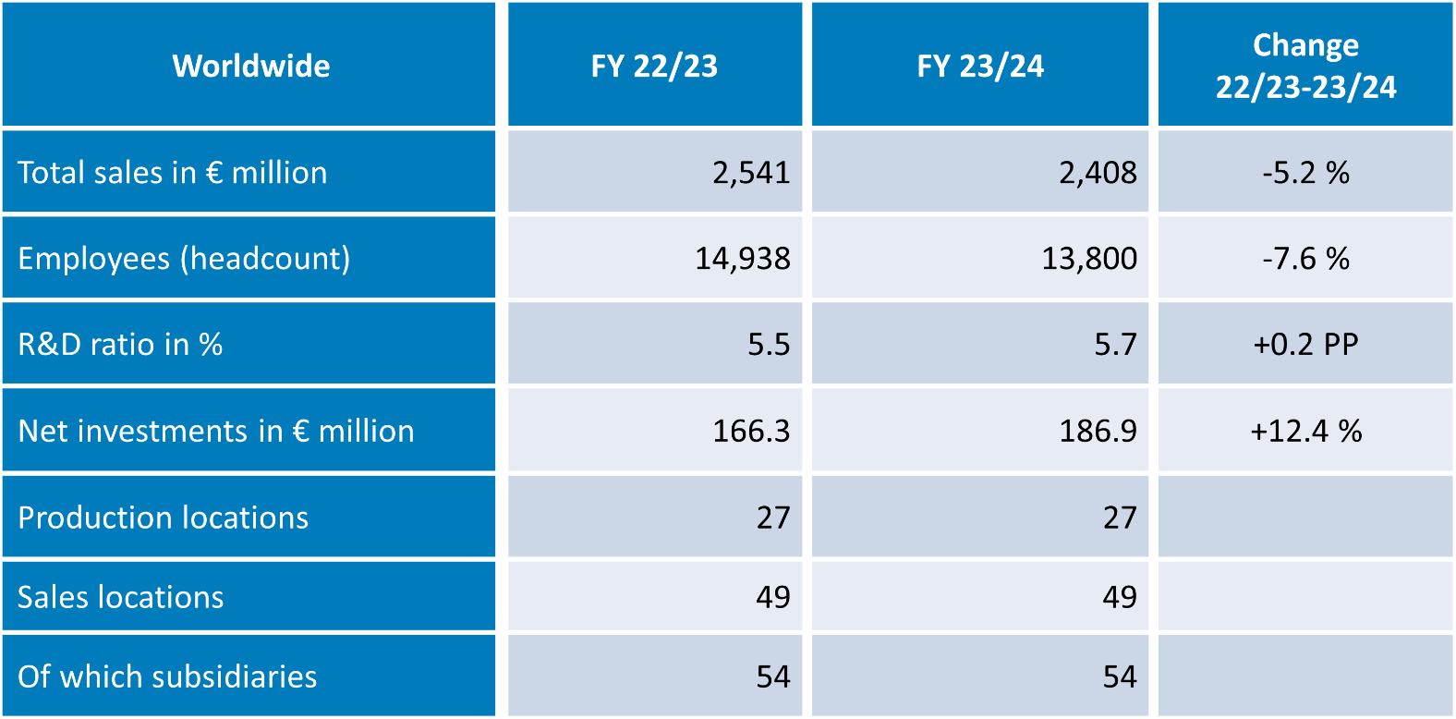

**ebm-papst Group**

The ebm-papst Group, a family-run company headquartered in Mulfingen, Germany, is the world’s leading manufacturer of fans and motors. Since it was founded in 1963, the technological leader has set international industry standards with its core competencies in motor technology, electronics, digitalization, and aerodynamics.

ebm-papst offers sustainable, intelligent, and tailor-made solutions for virtually every requirement in ventilation and heating technology. ebm-papst sets the benchmark in almost all sectors, such as ventilation, air conditioning and refrigeration technology, heating technology, information technology, mechanical engineering, intralogistics, and medical technology.

In the 2023/24 financial year, the Group generated a turnover of EUR 2.540 billion. It employs just under 14,000 people at 30 production sites including in Germany, China, and the US, as well as 50 sales offices worldwide.