**First sustainability report of the ebm-papst Group published  
Motto "Clear vision, sustainable mission."**

# Mulfingen, 07/18/2024

ebm-papst Group, the world's leading manufacturer of fans and motors headquartered in Mulfingen, published its first voluntary sustainability report online today. Under the motto "Clear vision, sustainable mission.", the Group communicates on 40 pages about its sustainability projects and initiatives of the past financial year 2023/24.

Among other findings, ebm-papst reports that emissions in Scope 1,2 and 3* have been successfully calculated for the last three completed financial years: In the Scope 1 and 2 emission areas, ebm-papst achieved a decrease of 11.4 percent in the 2022/23 financial year and a decrease of 43.1 percent in the 2023/24 financial year. By purchasing green electricity, around 49.6 percent of all emissions were avoided in 2023. In Scope 3, 98% of emissions are caused by product use. To contribute to a reduction here as well, ebm-papst will continue to pursue the path it has already taken to work closely with customers and to implement intelligent solutions.

As part of a Double Materiality Assessment (DMA) carried out in 2023, ebm-papst identified the most important sustainability issues for the company with the help of a comprehensive stakeholder survey. A sustainability mission statement was derived from this analysis, which is based on the four cornerstones climate and environment, partnerships and responsibility, people and corporate culture, and systems and solutions. The sustainability report also follows this structure: Each chapter of the report represents one cornerstone of the sustainability mission statement and looks at the associated measures and content in detail.

**Legal framework of the report**

The sustainability report is based on the GRI standards and breaks down the information and insights according to this system. GRI (Global Reporting Initiative) is an independent international organization that develops globally recognized standards for corporate sustainability reporting. As a globally active company, ebm-papst is committed to the goals of the United Nations and is currently focusing its sustainable activities on a selection of ten of the 17 Sustainable Development Goals (SDGs 3-9, 12, 13 and 1; SDGs = Sustainable Development Goals). From 2026, the Group will be subject to the new EU directive on sustainability reporting (CSRD= Corporate Sustainability Reporting Directive). Accordingly, in the 2025/26 financial year, ebm-papst will publish its sustainability activities in a standardized sustainability report for the first time.

**Information on the print and online version**

In the aftermath, the current sustainability report will also be published in a print run of 1,000 copies each (German and English). The used paper is “Blue Angel” and “FSC” certified. ebm-papst has deliberately kept the print run small to minimize the use of resources. To supplement the report, we use QR codes to link to additional online texts.

The sustainability report can be found on the [Group's website](https://www.ebmpapst.com/sustainability) and in its [online.mag](https://mag.ebmpapst.com/sustainability-report-2023-2024), where it also contains additional articles.

* Greenhouse gas emissions of a company are divided into three scopes. Scope 1 refers to direct emissions from own or controlled sources. Scope 2 describes indirect emissions from the generation of purchased energy. Scope 3 emissions are all indirect emissions (not in Scope 2) that arise in the reporting company's value chain, including upstream and downstream emissions.

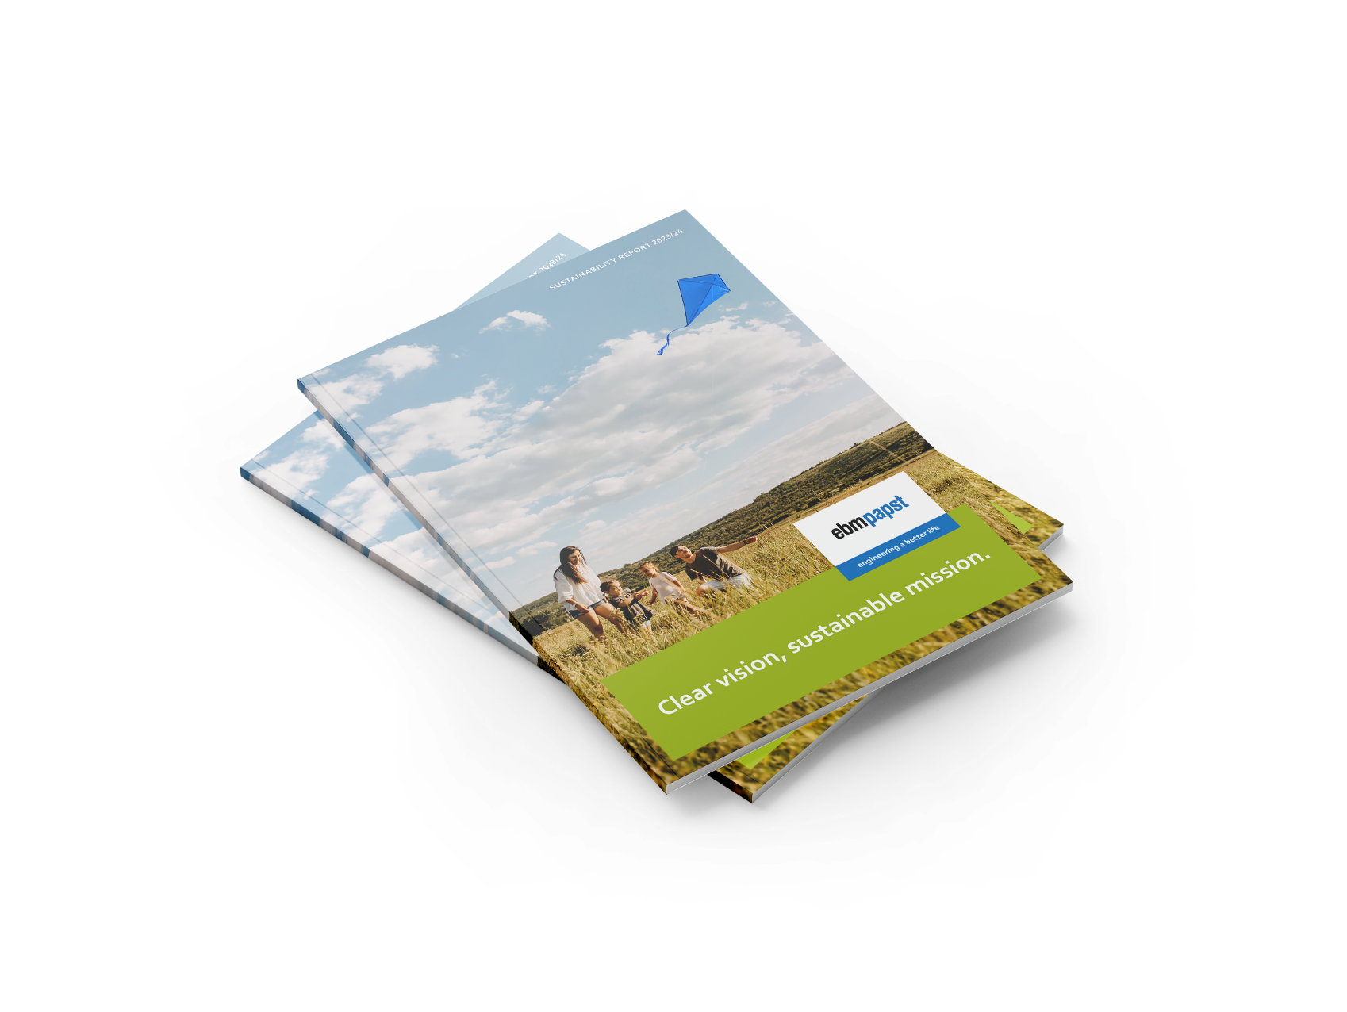

**Caption:** ebm-papst published its first voluntary sustainability report under the motto "Clear vision, sustainable mission". © ebm-papst Group   
[© Mr.Mockup – stock.adobe.com](https://stock.adobe.com/de/search/templates?filters%5Bcontent_type%3Atemplate%5D=1&filters%5Bfetch_excluded_assets%5D=1&filters%5Bcontent_type%3Aphoto%5D=0&filters%5Bcontent_type%3Aillustration%5D=0&filters%5Bcontent_type%3Azip_vector%5D=0&filters%5Bcontent_type%3Avideo%5D=0&filters%5Bcontent_type%3A3d%5D=0&filters%5Bcontent_type%3Aaudio%5D=0&filters%5Binclude_stock_enterprise%5D=0&filters%5Bcontent_type%3Aimage%5D=0&k=magazin+cover&order=relevance&safe_search=1&limit=100&search_page=2&search_type=pagination&acp=&aco=magazin+cover&get_facets=0&asset_id=813684789)

**About ebm-papst Group**

The ebm-papst Group, a family-run company headquartered in Mulfingen, Germany, is the world’s leading manufacturer of fans and motors. Since it was founded in 1963, the technological leader has set international industry standards with its core competencies in motor technology, electronics, digitalization, and aerodynamics.

ebm-papst offers sustainable, intelligent, and tailor-made solutions for virtually every requirement in ventilation and heating technology. ebm-papst sets the benchmark in almost all sectors, such as ventilation, air conditioning and refrigeration technology, heating technology, information technology, mechanical engineering, intralogistics, and medical technology.

In the 2023/24 financial year, the Group generated a turnover of EUR 2.540 billion. It employs just under 14,000 people at 30 production sites including in Germany, China, and the US, as well as 50 sales offices worldwide.